

*USER INSTRUCTIONS*

**ASSET MANAGEMENT SYSTEM (AMS)**

Contents

1 PREFACE 3

1.1 Description of the user 3

1.2.0 Understanding the User Interface 3

1.2.1 Logging into the System……………………………………………………………………………………. 3

1.2.2 Dashboard………………………………………………………………………………………………………….4

1.2.3 Items in the system…………………………………………………………………………………………...5

1.2.4 Accessing items in the system………………………………………………………………….………..6

1.2.5 Adding a new asset and printing ………………………………………………………………….……7

1.2.6 Edit and Delete ………………………………………………………………………………………………...8

1.2.7 Delete …………………………………………………………………………………………………………….…9

1.2.8 Save ……………………………………………………………………………………………………………….…9

1.2.9 Entries and Search Items ………………………………………………………………………………...10

1.2.10 Log out ………………………………………………………………………………………………………….11

# PREFACE

## Description of the user

This user manual is intended for use by the Administrator and Human Resources. Describes how the user enters the system, edits, searches, prints, and exits from the system.

## 1.2.0 Understanding the User Interface

1.2.1 Logging into the AMS System

* This section explains how to log in to your system. The user account and the password created are necessary to complete this step. If the user has forgotten his/her user account, the NCC’s IT Department will assist.
* Any user can now log in when the display looks similar to the picture below:
* To log in, type your username and password into the horizontal fields.
* For security reasons, a dot is displayed for every character entered in the password field.

1.2.2 Dashboard

* This section explains how to access all the assets in the AMS.
* The user will click on the arrow pointing to the right for the display of all the assets already in the system.
* The display looks similar to the picture below:

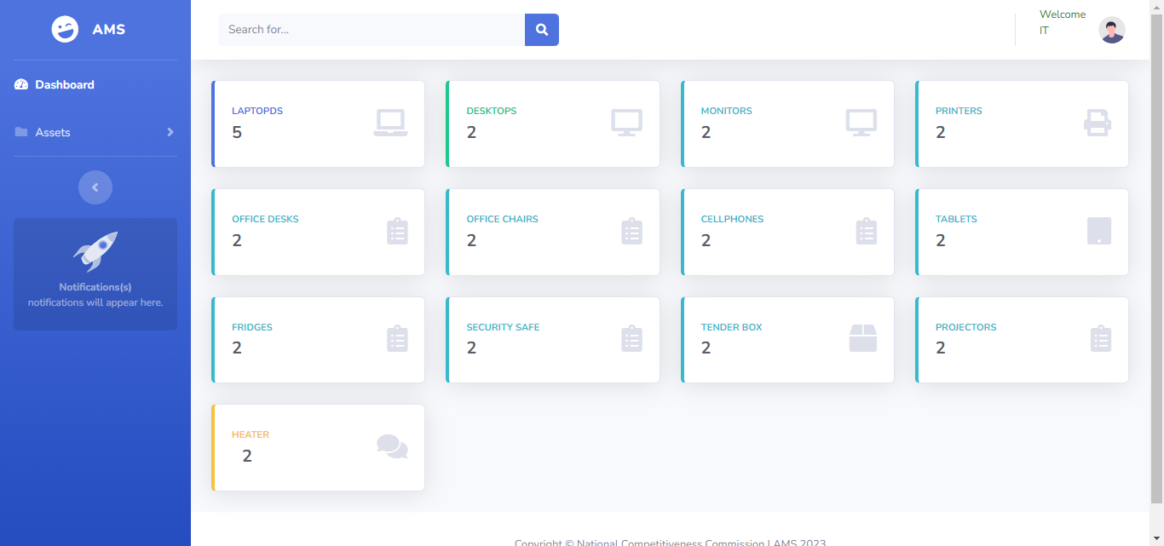

1.2.3 Items in the System

* The screen below will appear showing all the names of items in the system and the number of the captured items.

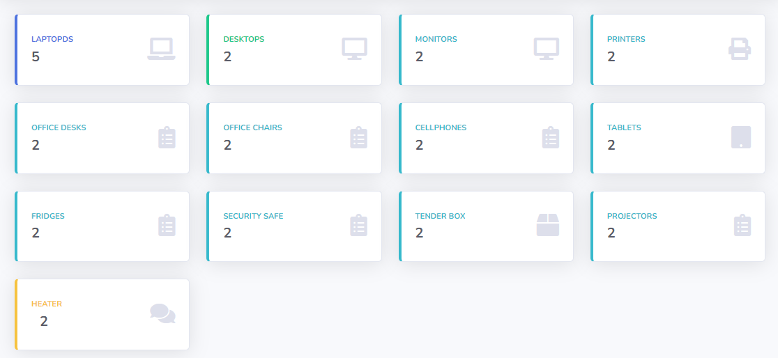

1.2.4 Accessing Items in the System

* The user will then access the items via the dashboard, by first clicking the arrow next to the “Assets” title and a drop-down menu appears with a list of assets in the system.
* The user can then choose the asset to work on by clicking on it.

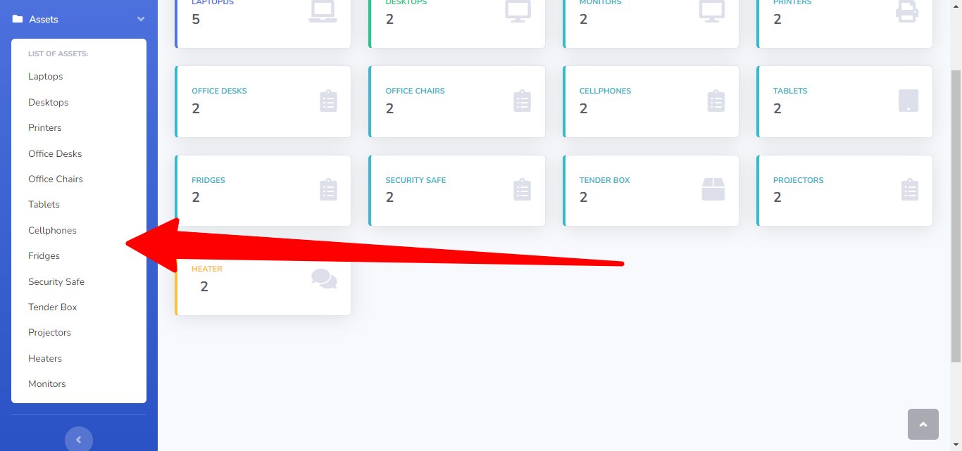

1.2.5 Adding a New Asset and Printing

* This section explains how to add new assets to your system and print reports.
* To add a new asset, the user clicks on the blue button labeled “**New**” and a new screen appears with blank fields to fill in.

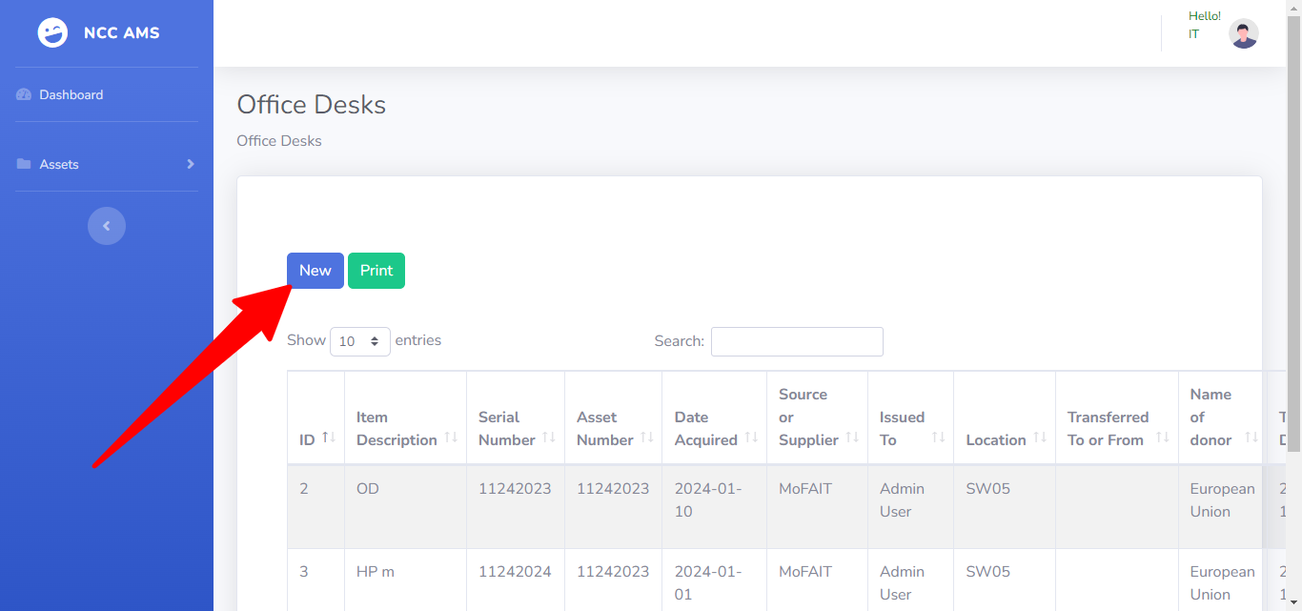

* If the user decides to print a report, he/she will then click the green button labeled “**Print**”.
* The display will look similar to the pictures below:

1.2.6 Edit and Delete

* The User can edit the information but with no rights to make use of the “**delete**” button.
* To view other sheets, if they happen to be available, the user will make use of the “next” or “**previous**” command buttons.
* The display will look similar to the picture below:

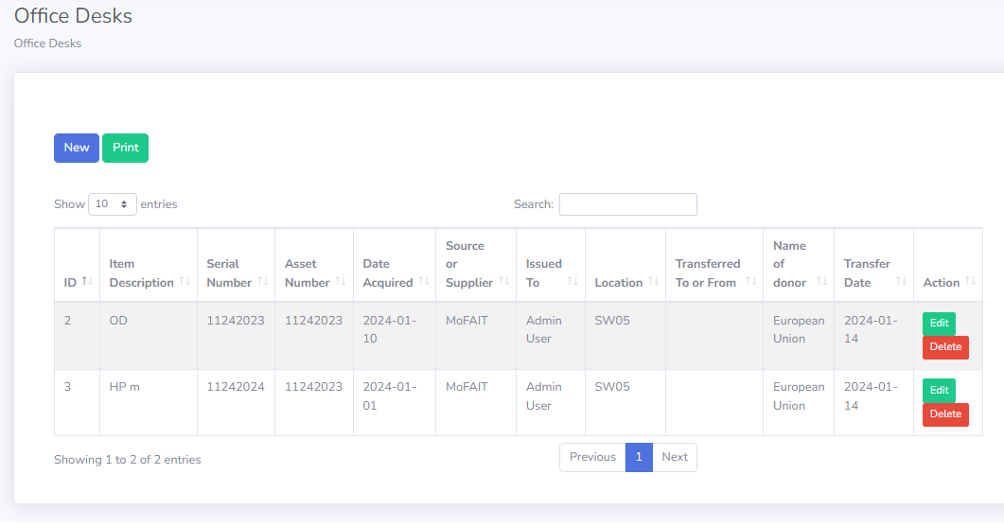

1.2.7 Delete

* The display will look similar to the pictures below, wherby the user chooses to either delete or cancel the operation.

1.2.9 Entries and Search Items

* A similar image to the one below, will show up, displaying the number of items with an option to make changes of even up to 100 entries.
* To the far right, is a search bar for easy access to records.

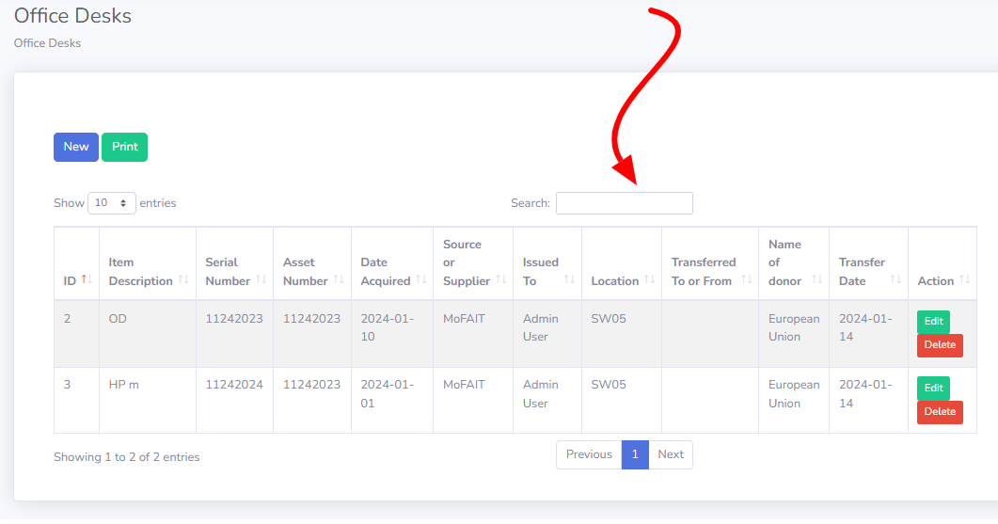

1.2.10 Logout

* This section explains how to log out of the AMS system.
* The user simply clicks on his/her profile as it appears in the top right corner whereby a drop-down menu appears for the selection of the log-out option.

